|  |  |  |
| --- | --- | --- |
| Screens To Design | Done | Put into documentation |
| Loading | Yes | Yes |
| Start | Yes | Yes |
| Create Account | Yes | Yes |
| Login | Yes | Yes |
| View Leaderboard | Yes | Yes |
| Choose Game | Yes | Yes |
| Student Menu | Yes | Yes |
| Student View Homeworks | Yes | Yes |
| End Game | Yes | Yes |
| Game – Linear Spaceship Wars | Yes | Yes |
| Game – Speed Maths | Yes | Yes |
| Game – Algebra Millionaire | Yes | Yes |
| Teacher Add Class | Yes | Yes |
| Teacher Homework Menu | Yes | Yes |
| Teacher Main Menu | Yes | Yes |
| Teacher Set Homework | Yes | Yes |
| Teacher View Classes | Yes | Yes |
| Teacher View Homeworks | Yes | Yes |

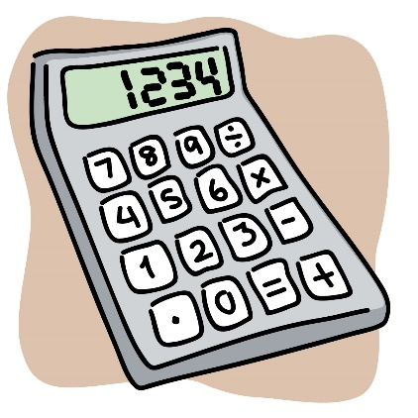

Loading…

Login

Create Account

Competitive Maths Games

Login

Username:

Password:

Login

Main Menu

Add Class

View Classes

View Homeworks

View Leaderboards

Play Game

Main Menu

Game #2

Game #2

Game #1

Select Game

Name

View Leaderboards

Game

Class Name

Score

Person 1

Score

Score

Score

Person 2

Person 3

Class

Game

Length

Due Date

Class 1

Class 2

Class 2

Game 1

Class 1

Game 2

30 mins

30 mins

15 mins

05/08/19

05/08/19

05/08/19

View Homeworks

Game Over

You scored: 5

Main Menu

View Leaderboards

Play Again

Homework Menu

View Homeworks

Set Homework

Add Class

Class Name

School Year

Students Selected

Enter Student Name

Person #2

Person #1

Person #5

Person #3

Person #6

Person #4

Add Class

View Classes

View Leaderboards

Homeworks

View Homeworks

Yes

Yes

No

Name 1

Name 2

Name 3

Name

Homework Completed?

15 mins

20 mins

10 mins

Time Spent

Add Homework

Game

Class Name

Homework Name

Homework Length

Due Date

Submit

|  |  |  |  |  |  |  |  |  |  |
| --- | --- | --- | --- | --- | --- | --- | --- | --- | --- |
|  |  |  |  |  |  |  |  |  |  |
|  |  |  |  |  |  |  |  |  |  |
|  |  |  |  |  |  |  |  |  |  |
|  |  |  |  |  |  |  |  |  |  |
|  |  |  |  |  |  |  |  |  |  |
|  |  |  |  |  |  |  |  |  |  |
|  |  |  |  |  |  |  |  |  |  |
|  |  |  |  |  |  |  |  |  |  |
|  |  |  |  |  |  |  |  |  |  |
|  |  |  |  |  |  |  |  |  |  |

Fire Laser

x +

y =

Score: 5

50:00

65 : 00

|  |  |  |
| --- | --- | --- |
| 54 | 15 | -34 |
| 4 | 16 | 22 |
| -10 | 7 | -8 |



7 + 8

15

4

10

8

3x + 14 = 35

30 : 00

|  |
| --- |
| 1000000 |
| 500000 |
| 250000 |
| 125000 |
| 64000 |
| 32000 |
| 16000 |
| 8000 |
| 4000 |
| 2000 |
| 1000 |
| 500 |
| 300 |
| 200 |
| 100 |

